CSUS EEE 174 Lab - Section 4 - Tuesday

Laboratory Experiment Number 6: Lab Report

**Raspberry Pi**



**Introduction**

The purpose of this lab is to explore the Raspberry Pi microcontroller. The Raspberry Pi is a low cost, small-sized, mini-computer that enables the user to create a home media center, internet radio, or even your own VPN server. In the first part of this lab, we learn how to setup the Raspberry Pi and have it displayed on the screen. In the second part, we explore and choose to build one out of a lot of great applications in the Pi.

1. **Raspberry Pi Setup**

First step of the Setup process is to install an Operating System (OS) for the Raspberry Pi. In order to set up the Raspberry Pi, we were required to download the latest version of the Raspbian at RaspberryPi.org/downloads. The next step required that we insert the SD card into the raspberry PI and connect all your cables (HDMI cable). Once the setup is completed, we power up the Raspberry Pi by plugging in the usb plot, which acts as a power supply for the Pi. Finally, the third step required that we configure the Raspbian by choosing expand_fs to expand the file system in the SD card in order for Raspbian to use the entire SD card. Afterwards, we enter the username and password so that we are able to see the user interface of Raspberry Pi with very friendly background like the picture below:

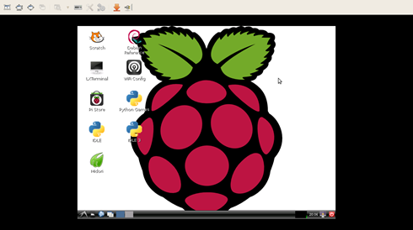

1. **Raspberry Pi Application**

In this part, from the suggested applications that can be operated in Raspberry Pi, we decided to emulate the game called “Flares.” Flare (Free Libre Action Roleplaying Engine) is a simple game engine built to handle a very specific kind of game: single-player 2D action RPGs. Flare is not a reimplementation of an existing game or engine. It is a tribute to and exploration of the action RPG genre. The first game, in progress, is a fantasy dungeon crawl. Below are some screenshots from the game.

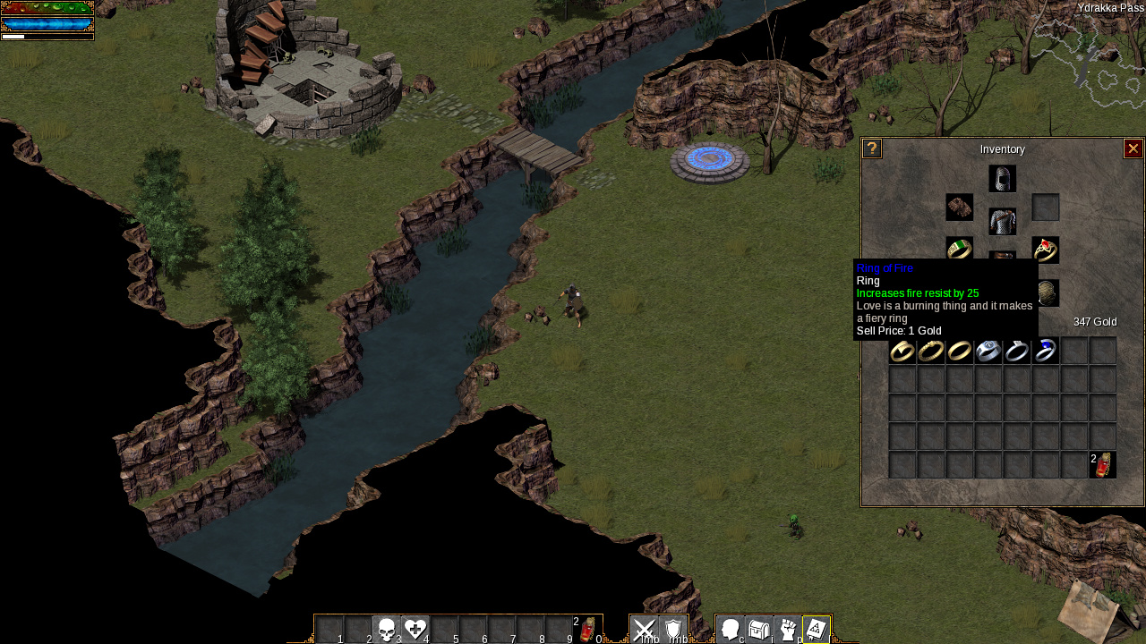

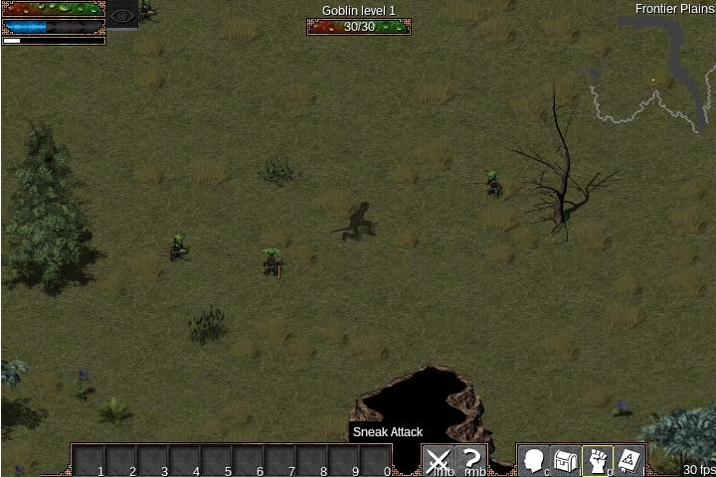

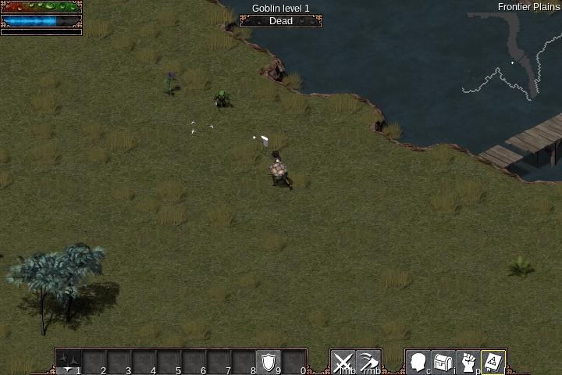

**Conclusion**

The purpose of this lab is to explore the Raspberry Pi microcontroller. To me, this is basically a mini and portable computer, which is powerful enough to do any works that I need. Besides its popularity, a very strong community also helps create great projects on Raspberry Pi. Another amazing thing about Raspberry Pi is it is open-sourced project, so anyone, including me, can contribute to any projects that I am interested in such as Flare, for example.